Knights Tour

Program running:

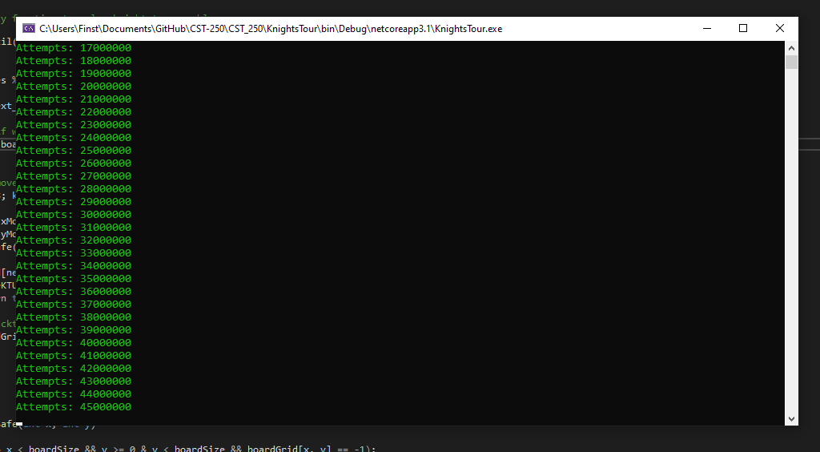

The program is recursively trying to move the Knight to every square on the board and calculating the number of moves to find a solution. I was unable to implement Warnsdorf’s method as the code examples provided are not self-documenting and very poorly written.